LearnHub: Your Center for Skill Enhancement

LearnHub is an intelligent online learning management system that leverages modern web technologies to provide structured, secure, and interactive digital education. It integrates full-stack development concepts using the MERN stack to enable course creation, video-based learning, secure authentication, payment verification, progress tracking, and automated certificate generation. The platform supports multiple user roles such as Admin, Teacher, and Student, ensuring controlled access and organized workflow management. Essentially, LearnHub is designed to create an efficient, user-friendly, and scalable digital learning environment that enhances knowledge sharing, simplifies course management, and promotes accessible education through technology.
IDEATION PHASE
Brainstorm & Idea Prioritization:
Brainstorming was conducted to explore different approaches for building a digital learning system. Initially, ideas such as a simple course listing website and a blog-based educational platform were considered. However, these ideas lacked structured course management, authentication mechanisms, payment verification, and progress tracking features. Through collaborative evaluation and prioritization, the team identified the need for a complete Learning Management System that supports secure authentication, role-based access control, payment simulation, video-based learning, progress tracking, and certificate generation.
Idea prioritization was performed based on feasibility, scalability, technical complexity, and real-world relevance. The MERN stack was selected due to its flexibility, performance, and industry demand. The final idea, LearnHub, was chosen because it delivers a complete LMS lifecycle while demonstrating advanced backend development concepts.
REQUIREMENT ANALYSIS
Customer journey map:
Creating a customer journey map for LearnHub involves understanding how students, teachers, and administrators interact with the platform at different stages. The journey starts with registration and secure login, followed by course browsing, payment verification, enrollment, learning progress tracking, and certificate generation. Teachers manage course creation and uploads, while administrators oversee system control. This structured journey ensures a smooth, secure, and efficient digital learning experience for all users.
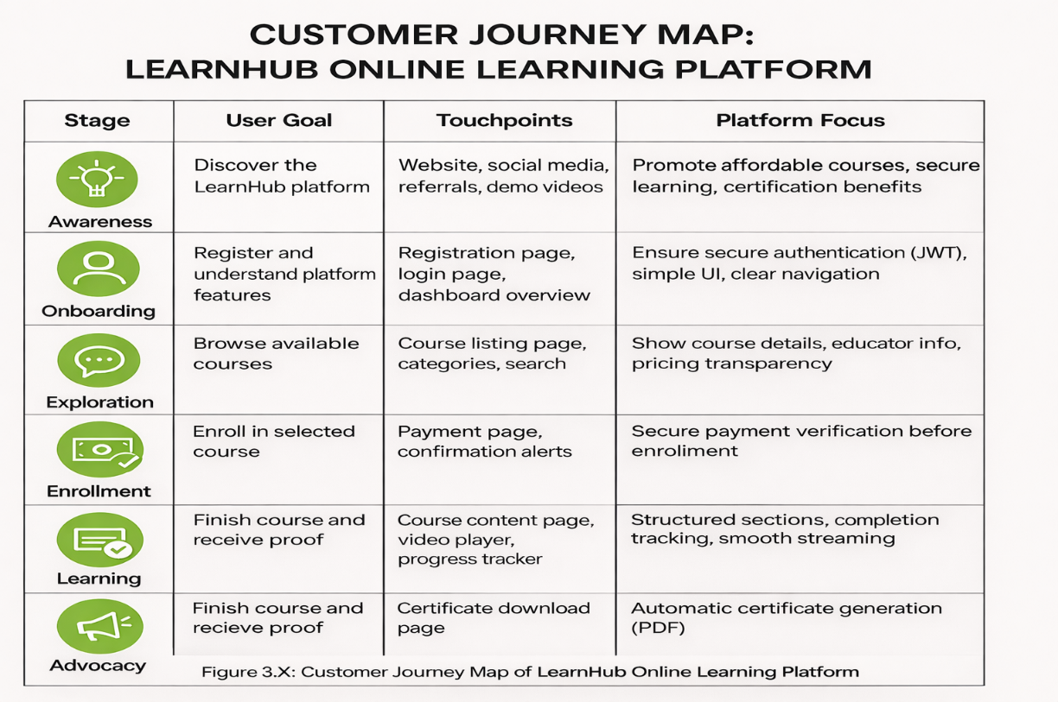

Data Flow Diagram:
LearnHub is a digital Learning Management System designed to help students, teachers, and administrators manage online education efficiently using modern web technologies. It integrates technologies such as the MERN stack, JWT authentication, and database management to handle course creation, secure login, payment verification, video-based learning, progress tracking, and certificate generation. By combining structured course management with secure authentication and automated workflows, LearnHub ensures a smooth, organized, and scalable online learning experience for all users.
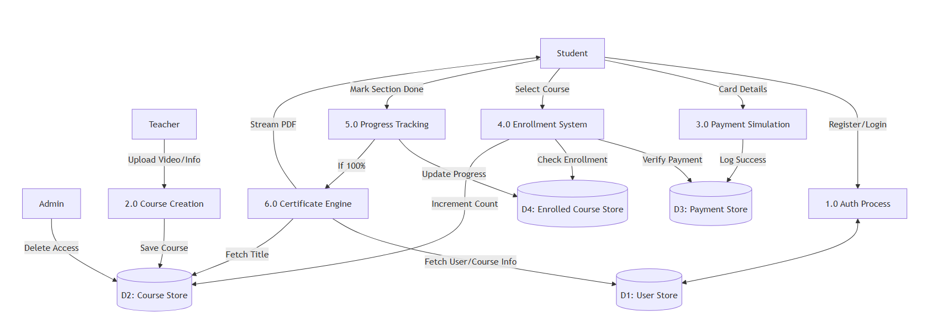
Technology stack:
To build the LearnHub Online Learning Platform, a robust and scalable MERN stack technology stack is used to ensure secure authentication, structured course management, payment verification, and seamless user interaction.
Layer | Technologies / Tools | Purpose
User Interface (UI) | React.js, Bootstrap, CSS | Interactive web interface for students, teachers, and admin dashboards
Application Layer | Node.js, Express.js | Backend business logic, REST API routing, role-based access control
Authentication & Security | JWT (JSON Web Token), bcrypt | Secure login, password hashing, role-based authorization
Data Layer | MongoDB, Mongoose | Structured data storage for users, courses, payments, enrollments
File Handling Layer | Multer | Video file uploads and storage management
Certificate Generation | PDFKit | Dynamic certificate generation in PDF format
API Communication | RESTful APIs, Axios | Frontend-backend communication
Deployment & Environment | Node runtime, Git, npm | Version control and application environment management

Technical Architecture:
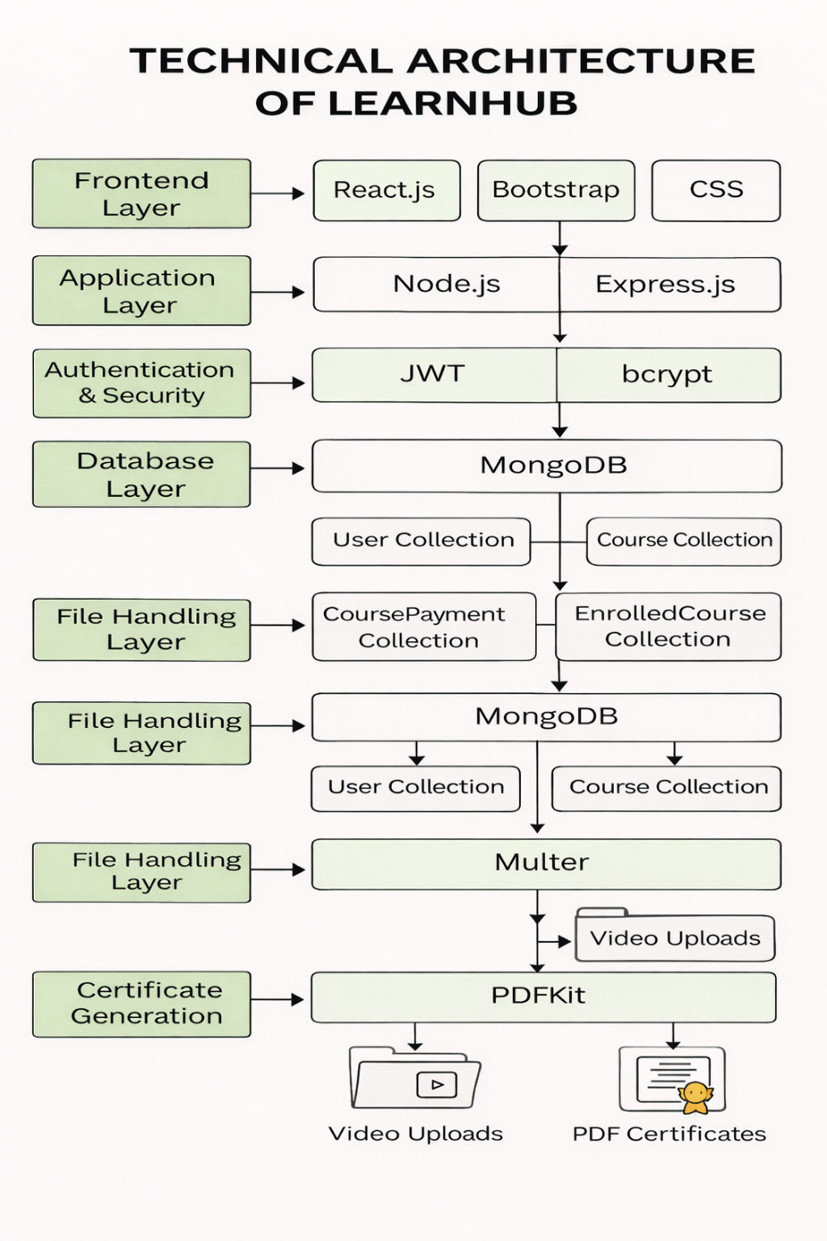

DESIGN PROJECT
Problem solution Fit:
• Students lack structured progress tracking and proof of completion
→ LearnHub provides section-based progress tracking and automatic certificate generation after course completion.
• Teachers face difficulty managing and organizing video content
→ LearnHub offers a dedicated teacher dashboard with structured video uploads and course management features.
• Enrollment without payment verification can cause misuse
→ LearnHub ensures secure payment simulation and verifies payment before allowing enrollment.
• Administrators need control over platform content and user roles
→ LearnHub implements role-based access control (Admin, Teacher, Student) using JWT authentication.
• No centralized system for managing courses, payments, and progress
→ LearnHub integrates course management, payment processing, enrollment tracking, and certificate generation into a single unified system.
• Lack of secure authentication in many learning systems
→ LearnHub uses JWT and bcrypt to ensure secure login and password protection.
Proposed solution:
1 Role-Based Learning Management System
- Separate dashboards for Admin, Teacher, and Student.
- Secure authentication and authorization using JWT.
2 Video-Based Course Management
- Teachers can upload structured video lessons using Multer.
- Courses organized into sections for better learning flow.
3 Secure Payment & Enrollment System
- Payment verification required before course enrollment.
- Payment records stored in CoursePayment collection.

4 Progress Tracking System
- Tracks completed sections.
- Automatically updates course completion status.
5 Automated Certificate Generation
- PDF certificate generated using PDFKit.
- Available only after course completion.
6 Scalable MERN Architecture
- React frontend for interactive UI.
- Node.js & Express backend for API management.
- MongoDB for data storage and scalability.
7 Secure & Structured Workflow
- Role-based middleware protection.
- RESTful API communication between frontend and backend.
Solution Architecture:
- User Interaction Layer
  - Interfaces: Web application (React.js)
  - Purpose: Allows students, teachers, and admins to interact with the system
- Application & Service Layer
  - Technologies: Node.js, Express.js
  - Functions: Handles business logic, routing, authentication, and workflows
- Authentication & Security Layer
  - Technologies: JWT, bcrypt
  - Purpose: Secure login, password hashing, role-based access control
- Data Management Layer
  - Databases: MongoDB
  - Stores: User data, course details, payment records, enrollment data, progress tracking
- File Handling Layer
  - Technology: Multer
  - Purpose: Upload and manage video course files
- Certificate Generation Layer
  - Technology: PDFKit
  - Purpose: Generate downloadable PDF certificates
- Integration & API Layer
  - Interfaces: RESTful APIs, Axios
  - Purpose: Connect frontend and backend seamlessly
- Deployment & Runtime Layer
  - Platform: Node.js runtime environment
  - Role: Server execution and system scalability
FUNCTIONAL AND PERFORMANCE TESTING
Functional Testing
- Verify user registration and login functionality works correctly with secure JWT authentication.
- Test role-based access control to ensure Admin, Teacher, and Student dashboards are properly restricted.
- Validate course creation and video upload functionality using Multer.
- Ensure payment simulation and enrollment workflows function correctly end-to-end.
- Confirm progress tracking updates correctly when students complete course sections.
- Verify certificate generation and PDF download after course completion.
- Test API endpoints for accurate data retrieval and updates (courses, payments, enrollments).
- Confirm password encryption using bcrypt and secure token validation.).

Performance Testing
- Conduct load testing to simulate multiple users accessing courses simultaneously.
- Perform stress testing to evaluate backend stability under high traffic conditions.
- Measure API response time for course listing, enrollment, and progress tracking.
- Test video streaming performance during concurrent access.
- Validate database query efficiency for large numbers of users and courses.
- Monitor server resource usage (CPU, memory, storage) during peak operations.
- Evaluate system scalability for increasing number of users and course uploads.
RESULTS
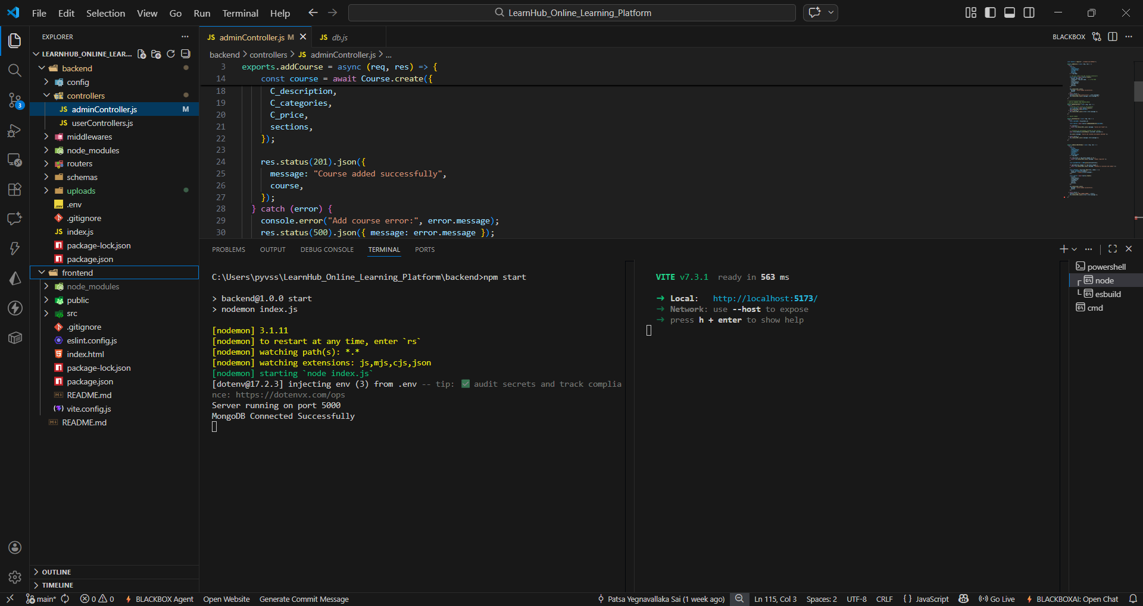
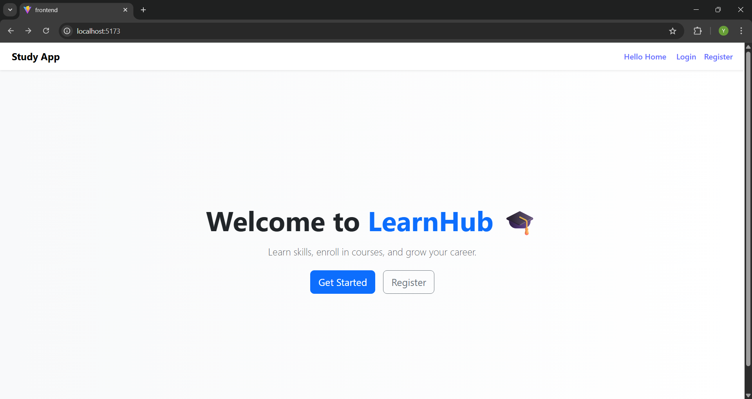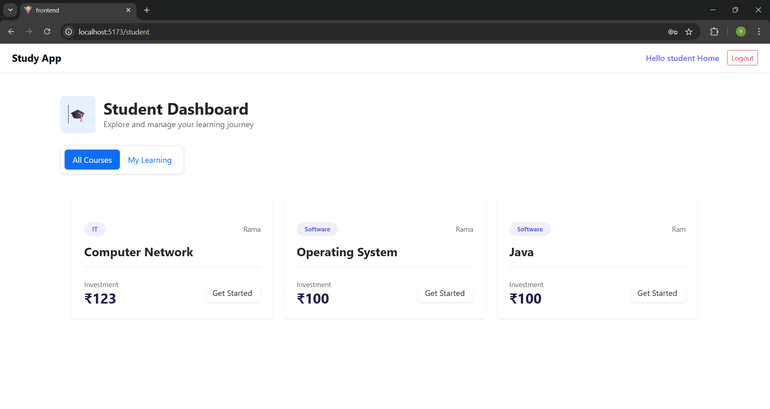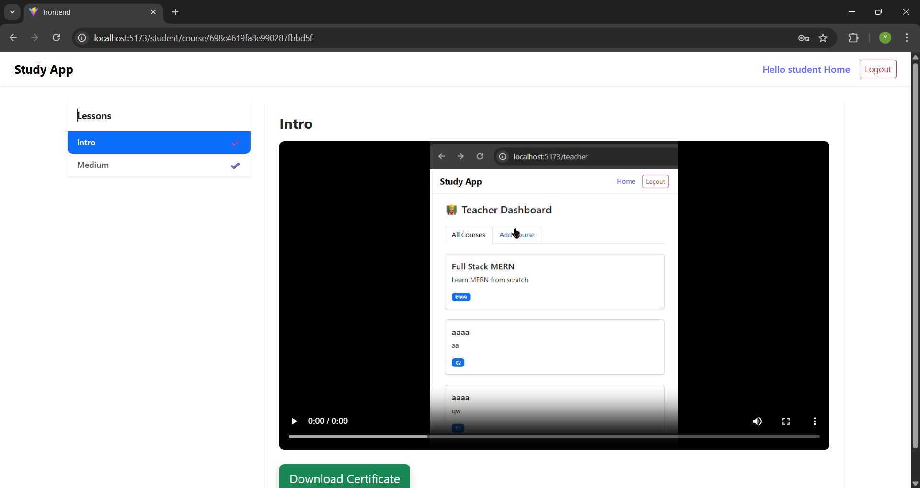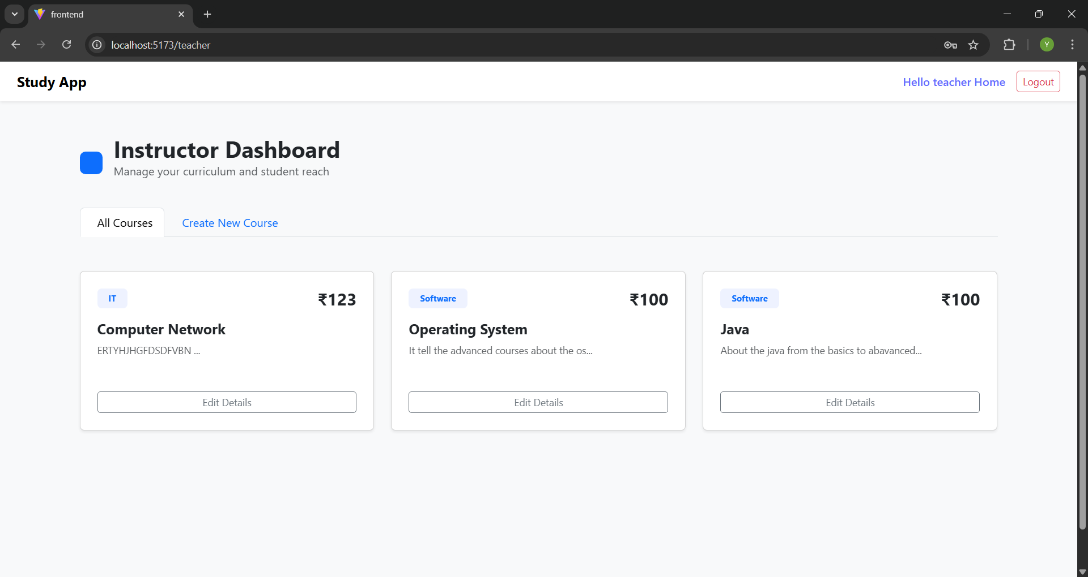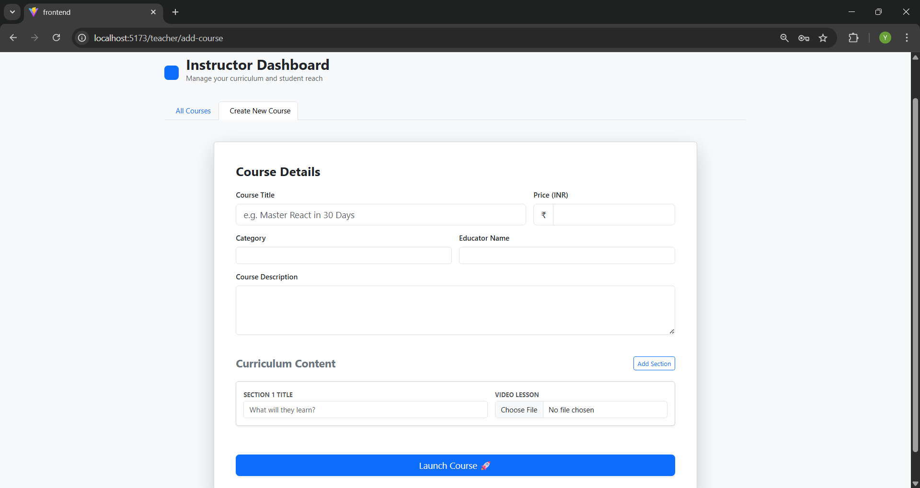
ADVANTAGES & DISADVANTAGES:
Advantages
- Provides Secure Authentication and Role-Based Access
- Enables Structured Video-Based Learning
- Supports Progress Tracking and Course Completion Monitoring
- Ensures Payment Verification Before Enrollment
- Automates Certificate Generation
- Offers Separate Dashboards for Admin, Teacher, and Student
- Scalable MERN Stack Architecture
- Organized Course and Enrollment Management
- Enhances Digital Learning Accessibility
- Demonstrates Real-World Full-Stack Development Implementation
Disadvantages
- Payment System is Simulated (Not Real Gateway Integration)
- Video Storage is Local (Not Cloud-Based)
- Requires Continuous Server Availability
- Limited Advanced Features (e.g., Live Classes, Chat System)
- Performance Depends on Hosting Infrastructure
- Initial Setup and Deployment Complexity
- No AI-Based Recommendation System
- Limited Offline Access
- Requires Regular Maintenance and Updates
- Scalability Depends on Database and Server Configuration

CONCLUSION
The LearnHub Online Learning Platform represents a comprehensive and scalable digital education solution built using the MERN stack. By integrating secure authentication, role-based access control, structured course management, payment verification, progress tracking, and automated certificate generation, the system delivers a complete Learning Management System experience.
LearnHub effectively bridges the gap between traditional education and modern digital learning by providing an organized and secure environment for students, teachers, and administrators. Its structured workflow, scalable architecture, and full-stack implementation demonstrate practical real-world application development skills.
However, the platform can be further enhanced by integrating real payment gateways, cloud-based video storage, AI-driven recommendations, and advanced interactive features. With continuous improvements and proper deployment strategies, LearnHub has strong potential to evolve into a fully functional, production-ready online learning system.
FUTURE SCOPE
- AI-Based Course Recommendation System
Machine learning algorithms can analyze user behavior and learning patterns to recommend personalized courses and learning paths.
- Real Payment Gateway Integration
Integration with secure payment platforms such as Razorpay or Stripe to enable real-time transactions instead of payment simulation.
- Cloud-Based Video Storage
Migrating video uploads to cloud platforms like AWS S3 or Google Cloud Storage for better scalability and performance.
- AI-Based Assessment & Auto-Grading
Implementing automated quizzes, assignments, and grading systems using intelligent evaluation models.
- Mobile Application Development
Development of Android and iOS applications to improve accessibility and user engagement.
- Analytics & Reporting Dashboard
Advanced analytics for tracking student performance, course popularity, and revenue statistics for teachers and administrators.
- Multi-Language Support
Enabling multilingual interfaces to support learners from different regions and backgrounds.

Submitted by:
Yegnavallaka Subrahmanya Sai Patsa
Chellaboina Rohith Venkata Srinivas
Dasari Keerthi Raju
Chikkala Vyshnavi

